CIRRASPEC COH  
User’s Manual

System Version: 3.0

Revision History

|  |  |  |  |
| --- | --- | --- | --- |
| **Document Version** | **Date** | **Name** | **Description** |
| 3.0 | 05/01/2017 | Sayali Dev | Created for COH Users workflow |

**Table of Contents**

Revision History 2

Accessing the Application 4

Login Guidelines 4

Logging into the Application 4

Logging off the Application 5

Accessing the Home Page 6

Accessing the My Account Page 7

To set user profiles on My Account page : 8

Site Settings 8

Changing Your Password 8

Navigating through the application: 9

Workflow for Nurses – At COH Hospital site 10

Creating/Maintaining a Patient Record 11

Create a Patient to order a test 11

Updating a Collection Event for a New Subject 13

Completing Requsition Forms for a Patient 14

Add the Collected Specimen to a Patient Record 18

Ship the specimens to the Speciality Lab 20

Login and Download Patient Sample Report 21

Reordering or Adding another order for a test for a Patient 23

# 

# Accessing the Application

To access the CIRRASPEC application, you must have a valid user name and password.

### Login Guidelines

* The password must contain a minimum of six characters and is case sensitive.
* The password must contain at least one alphabet, one number and one special character such as !, @, #, &, etc.
* The application prompts you to change your password after you login for the first time. For more information about how to change your password, see **[Changing Your Password](#ChangePassword)**.
* This application supports the following browsers:
  + Firefox 3.5 and above
  + IE 8.0 and above
* You must not run IE 8.0 in the Compatibility mode. You can check the IE compatibility view by clicking **Tools** > **Compatibility View settings**.
* You must ensure that any pop-up blocker software is turned off.

## Logging into the Application

To log in:

1. Enter CIRRASPEC web site URL In the address bar of a Web browser.

The **Login** page appears.

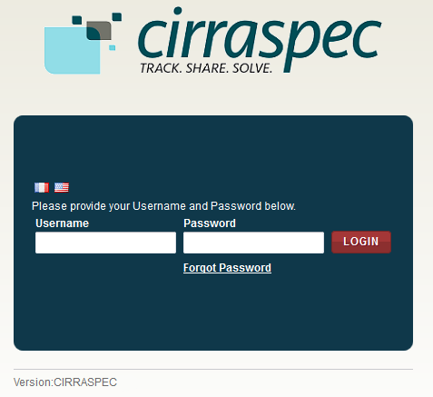

1. In the **Username** box, type your username and in the **Password** box, type your password.

**Note:**

If you have forgotten your login credentials or need login assistance, send an e-mail to [cirraspec@tgen.org](mailto:Bio4Dhelp@tgen.org).

1. Click **Login**.

The CIRRASPEC **home page** appears.

On top right, below the My Account link, Home page displays Welcome note:“Welcome User Sitename”

**Note:**

* If you have more than one assigned collection site locations, you are prompted to select the appropriate location for this Web session.
* Click on **SAVE,** the home page displays the location selected on top right Welcome note.

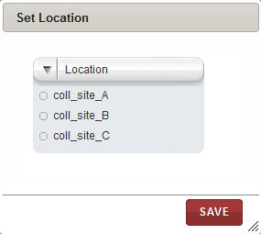

## Logging off the Application

To log off from the application, in the upper-right corner of any page, click the **Logout** link.

On successful logout, The **Login** page appears.

## Accessing the Home Page

You can access the CIRRASPEC home page from any other page by clicking the **Home** tab.

1. Allows you to access the CIRRASPEC home page
2. Allows you to access your account for password and user profile maintenance
3. Welcome note displaying user logging to the site
4. Allows you to log off from the application.
5. Easy Access Links

3

2

4

1

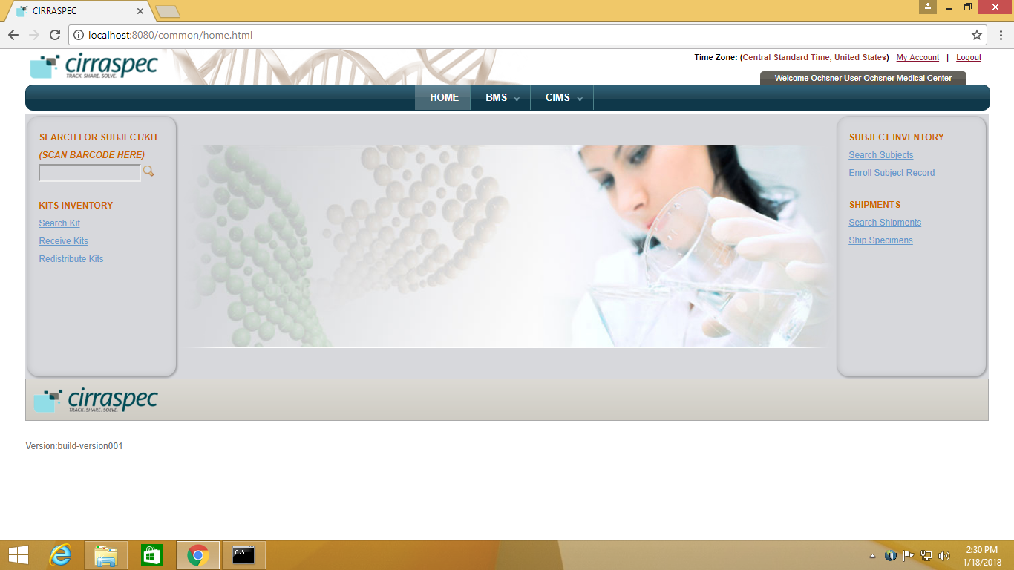

5

5

## Accessing the My Account Page

You can use the My Account page to update your user profile (language and location preferences) and your login password.

To access the **My Account** page:

1. In the upper-right corner of any page, click the **My Account** link.

The **My Account** page appears.

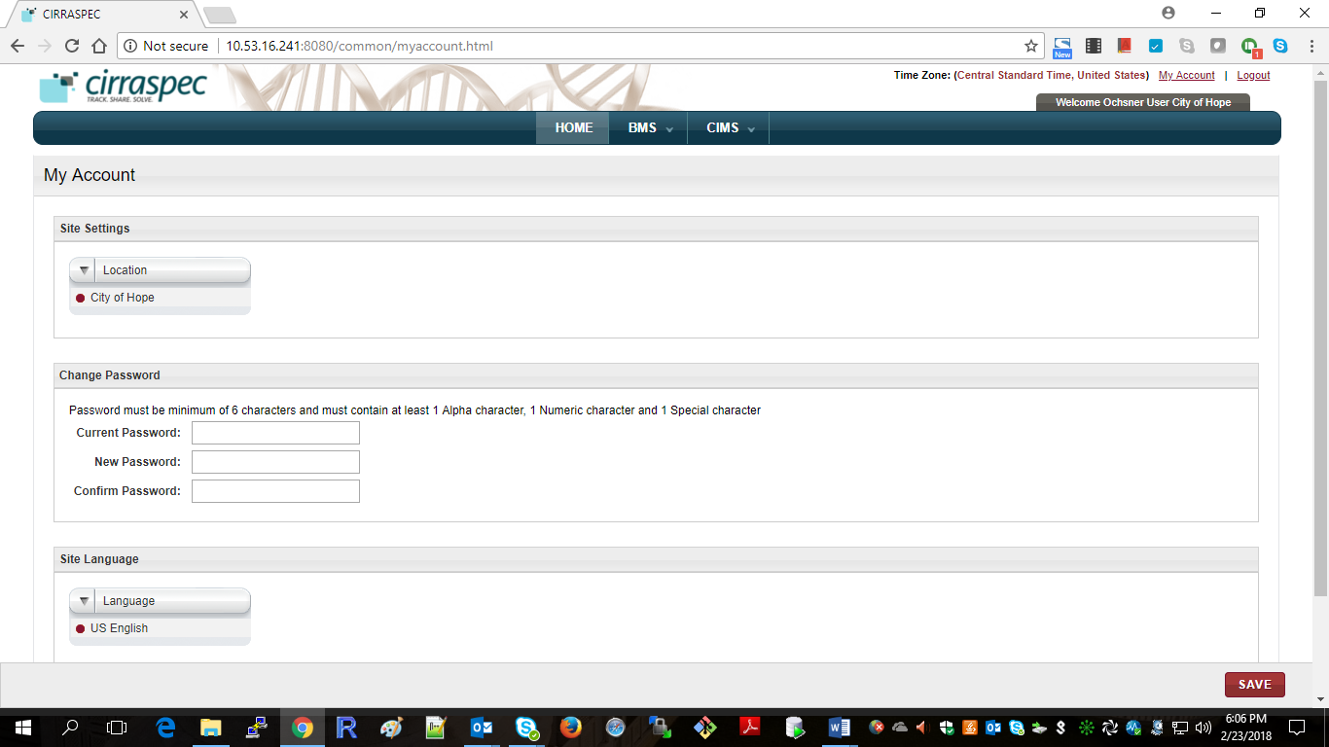

### 

### To set user profiles on My Account page :

### Site Settings

Allows you to select a different collection site location to view information and perform tasks associated with that location.

To select a different location:

1. Click on the **Location** list dropdown arrow.

Locations list displays all locations assigned to you based on your user role and access permissions.

1. Select the desired location.
2. Click **SAVE**.

The location is updated. Information associated with that location is displayed on the CIRRASPEC pages.

### Changing Your Password

Allows you to update the password for login to Cirraspec application.

Password Guidelines:

* The password must contain a minimum of six characters and is case sensitive.
* The password must contain at least one alphabet, one number and one special character such as !, @, #, &, etc.

To change your password:

1. In the **Current Password** boxof the **Change Password** area, type your current password.
2. In the **New Password** box, type a new password.
3. In the **Confirm Password** box, type the new password again.
4. Click **SAVE**.  
   Your password is changed.

**Note:** For assistance with the username or password, send an email to [cirraspec@tgen.org](mailto:Bio4Dhelp@tgen.org)

# Navigating through the application:

BMS tab:

|  |  |  |
| --- | --- | --- |
| Tab | Function | Events: |
| Shipments | Allows to ship specimens from collection site to Processing / LIMS site / biobank site. | Create specimen shipment, send shipment, Modify/delete shipments |

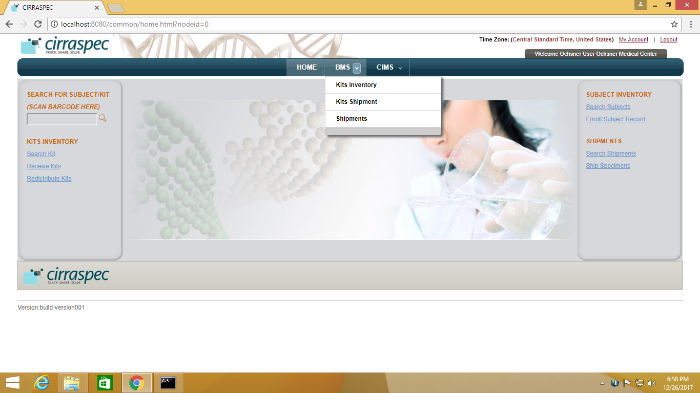CIMS tab:

|  |  |  |
| --- | --- | --- |
| Tab | Function | Events |
| Subject Centric View | Allows subject /donor / patient management | Update forms, assign kits to collection events, collect subject specimens, download reports. |

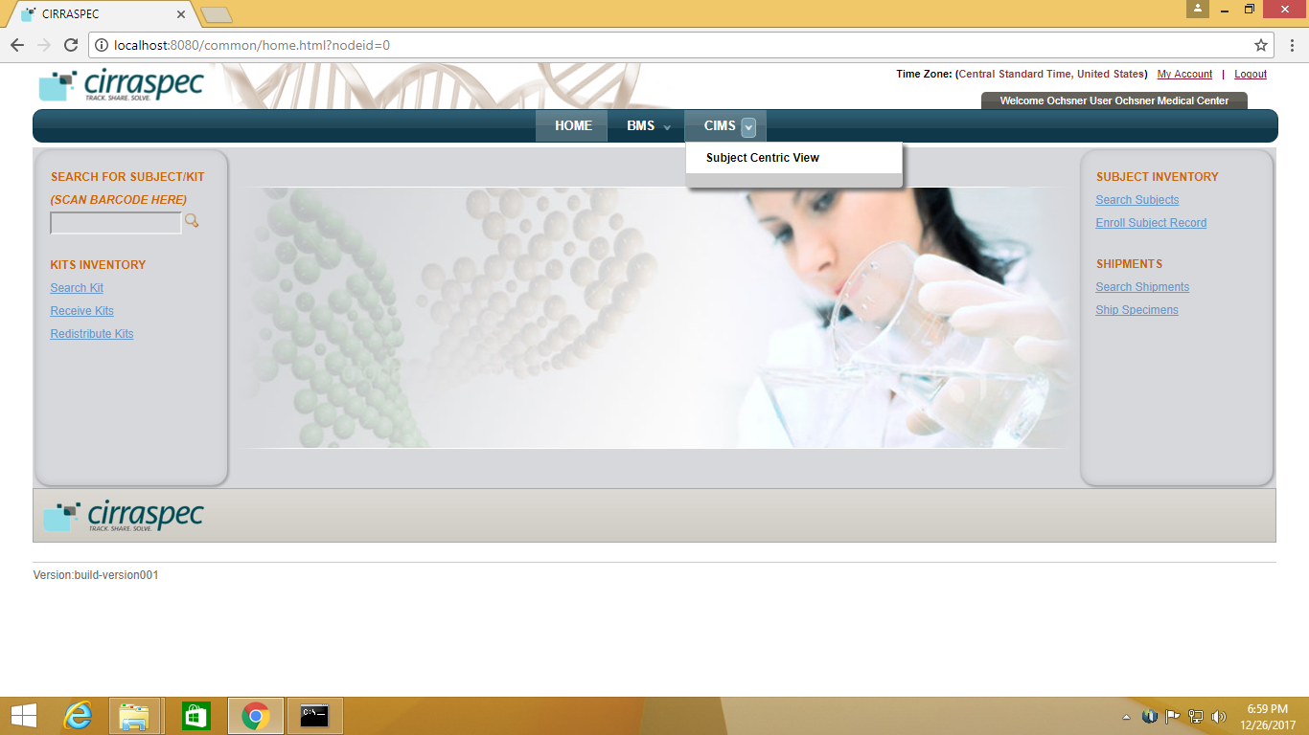

**NOTE:** You can scan barcode for the specimen /kit to enter source identifiers into the application.

# Workflow for Nurses – At COH Hospital site

Create a Patient in the system to order a test on page 11

Fill the online Specialty Lab ‘Requisition’ form. on page 13,14

Add the collected specimen(s) to the patient record. on page 18

Ship the specimens to Specialty Lab on page 20

Login to the system to download the final report on page 21

For Unscheduled Events:

Reordering or Adding another order for a test for a Patient on page 23

# Creating/Maintaining a Patient Record

### Create a Patient to order a test

To create a patient to order a test:

1. Point to the arrow of the **CIMS** tab, and then click **Subject Centric View**.

The **Subject Search** page appears.

1. Click the **Enroll New Subject** link

The **Create/Enroll Subject** page appears.

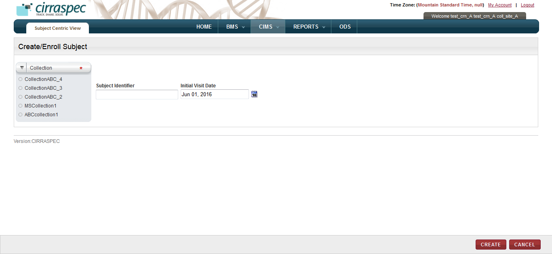

1. In the **Collection** list, you will see option selected as COH (clinical test) or ORIEN (research test).
2. Specify the **Subject Identifier**(optional) in the textbox provided.
3. Select the **Initial Visit Date** (optional) from the calendar. By default current date is displayed.
4. Click **CREATE**.

* The patient or subject is created and enrolled for the Collection / Test.
* The subject identifier if not entered, is created by system as configured for the collection.

**Note:**

Subject Identifier: MRN, Internal or Other can be added for enrolled patient.

To add identifier, follow below steps:

1. Click on default subject identifier

2. Select the Identiifer Type from dropdown

3. Enter the Identifier

4. Click on Save.

* Following will be shown for the patient created:
  + A Collection event for the order. Visit Date displays Current day’s date.
  + A Test Requisiton form

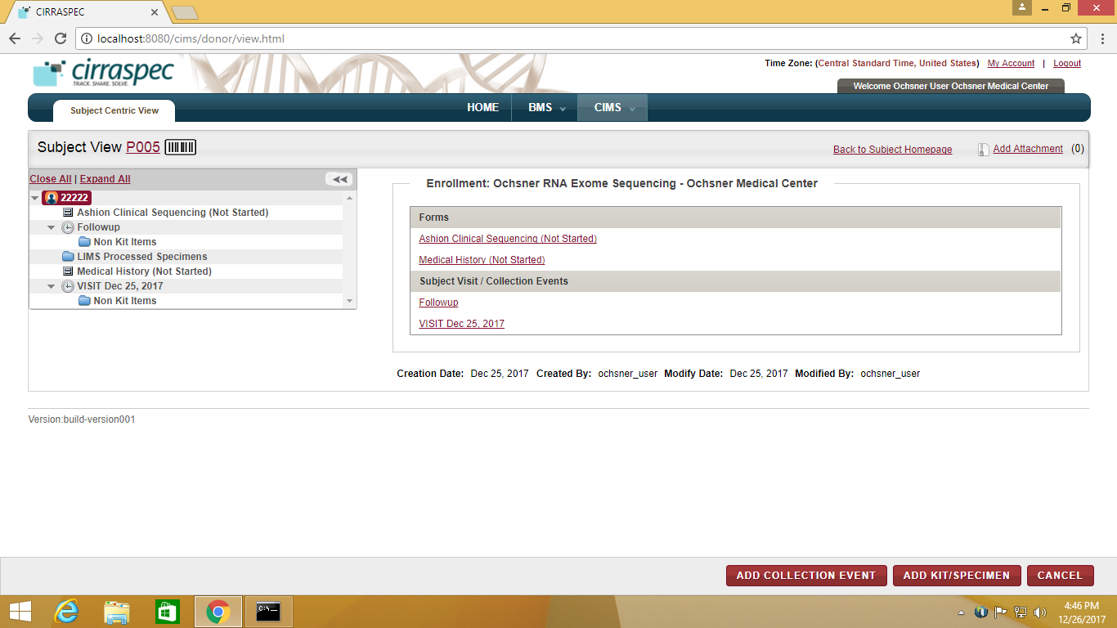

### Updating a Collection Event for a New Subject

Once a patient is registered, a collection event for order with current date is created.

To record the occurrence of a Collection Event:

1. Click the Collection Event link under the ‘**Subject Visit / Collection Events’ section** from the Subject Homepage

OR

In the hierarcy tree on the left, select/highlight the Collection Event node to update.  
The **View Collection Event** area appears on the right.  
  
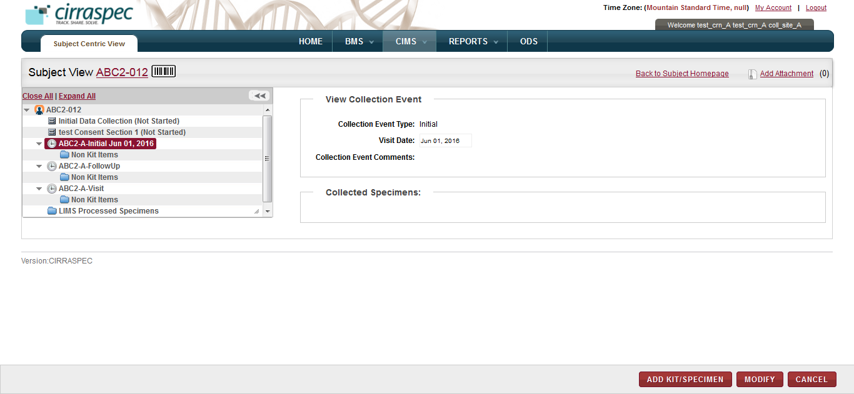

1. Click **MODIFY.**The appointment fields appear.
2. Select/change the **Visit Date** to specify the date/time of the order, if required.
3. Input **Collection Event Comments**, if needed.
4. Click **SAVE**.The Collection Event information is saved.

### Completing Requsition Forms for a Patient

To complete the requsition form for a Patient:

1. From the **Subject Homepage** on the right side of the page, under **Enrollment** section, click the link of the form.

OR

In the hierarchy tree structure on the left side of the page, click the form section node for which you want to fill up details.

Details of the selected form appear on the right side of the page.

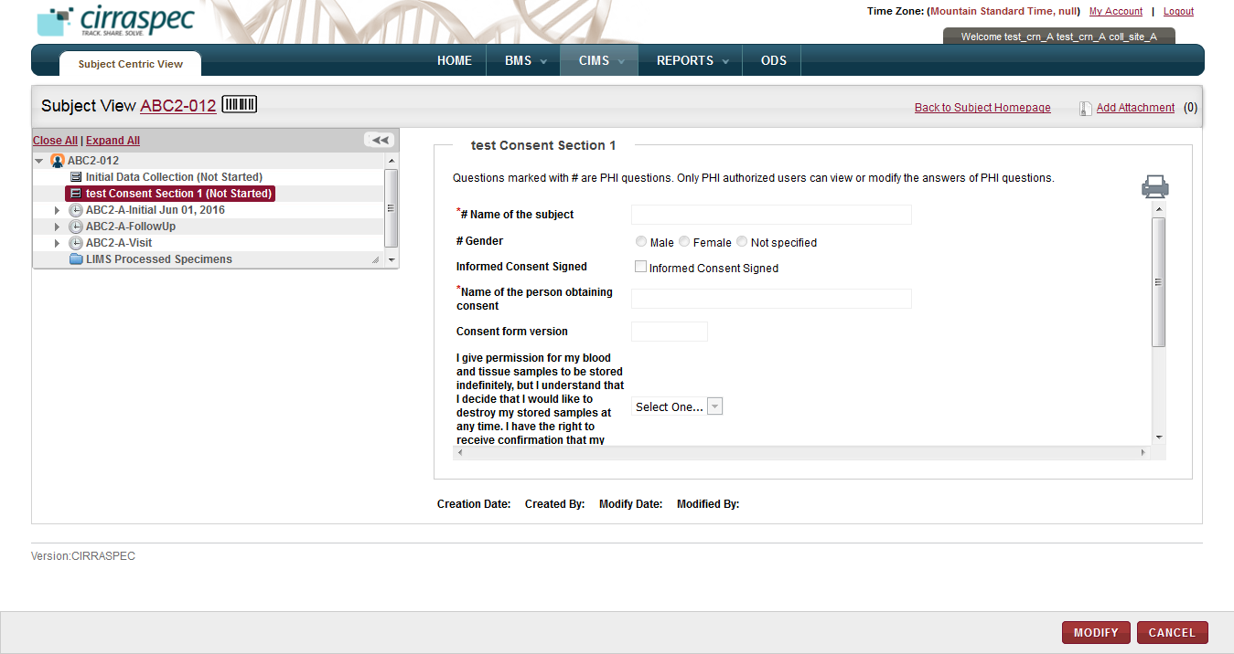

1. Click **MODIFY**.

The form data fields appear in modify mode.

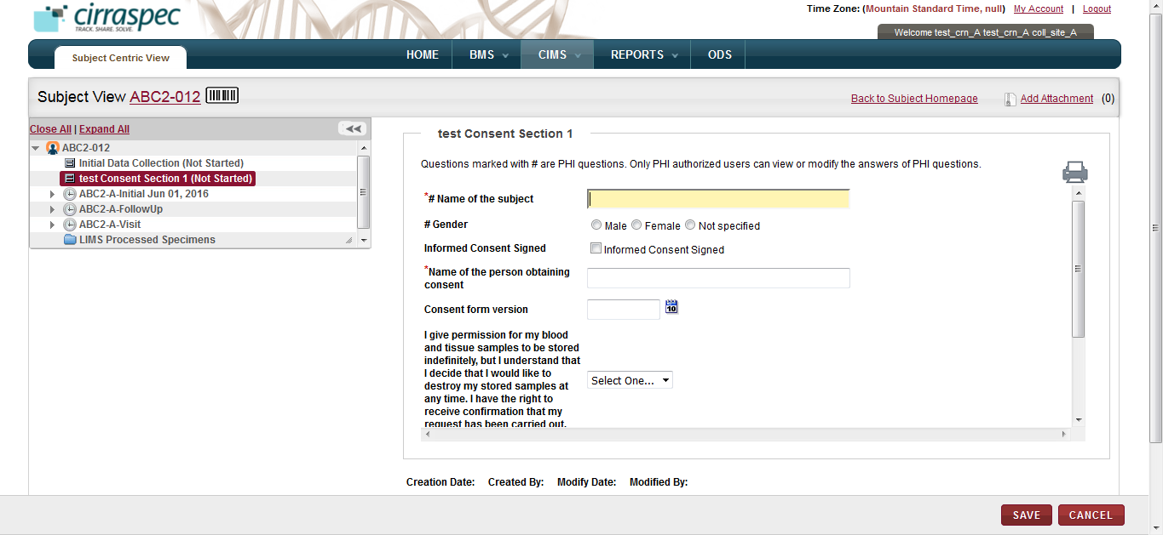

**Note**: PHI questions (if any) in the form would be marked with a hash sign (#).

If the form contains PHI questions, they would appear in a different fashion to the PHI and Non-PHI authorized users.

* PHI authorized users will be able to fill up answers for PHI as well as Non-PHI questions on clicking the MODIFY button.
* However, the Non-PHI authorized users will be able to fill up answers only for the Non-PHI questions.

The input fields for the PHI questions will appear greyed out when users clicks the MODIFY button.

Above screen shot shows how a form will appear for a PHI user. All the input fields will open up in the edit mode once user clicks MODIFY button.

Following is a screen shot showing how the form will appear for a Non-PHI user:

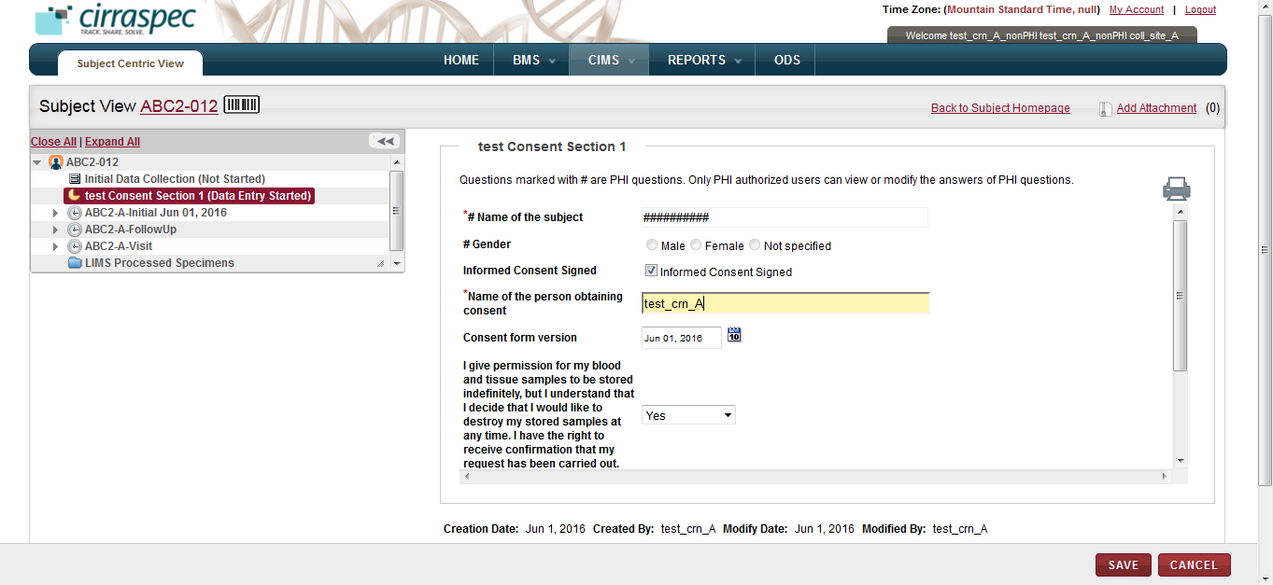

Notice how the questions marked with hash sign (#) appear in the greyed out mode in the above screen shot for the Non-PHI user.

**Note**: If PHI questions of the form have already been answered then:

* PHI authorized users will be able to view the answers.
* However, the Non-PHI authorized users will not the able to view the answers.
  + The answers will be blanked out in case of check-boxes, radio buttons and dropdowns.
  + The answers will be hashed out in case of textboxes.

1. Enter the form data and then click **SAVE**.

The changes are saved and the form section status appears as **Data Entry Started**.

**Note**:

* If a form contains PHI questions which have been marked mandatory (as in the above case), then the PHI users are not allowed to SAVE the form if the questions have not been answered.
* However the Non-PHI users are allowed to SAVE such a form in any case since they will not be able to fill up answers for the mandatory PHI questions.

1. If the form is complete, do the following:
2. Click **DATA ENTRY COMPLETED**.

The status of the form appears as **Data Entry Completed**.

1. Click **APPROVE**.

The status of the form appears as **Approved**.

**Note**: If the form has one or more PHI questions, then these options would not be shown to the Non-PHI authorized user since he would never be able to know if the answers to PHI questions have been filled up or not and hence will not be in a state to comment on the form status.

1. To view and/or print the form, click the **print icon** .  
   The form appears in a new window.   
   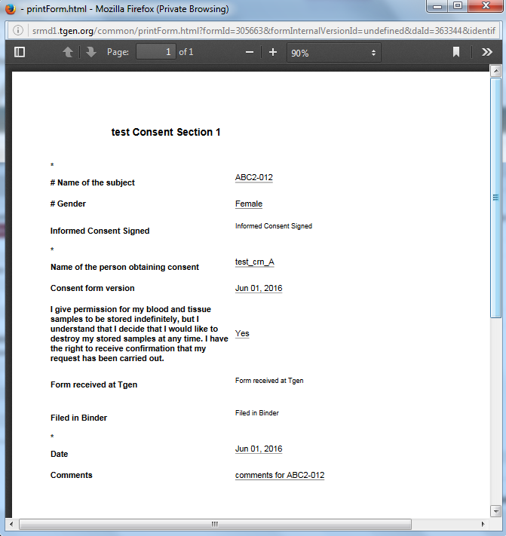
2. Click the **arrow icon **, and then select **Print** on the list of options.

The **Print** window appears. You can select a printer, specify number of copies and pages to print.

### Add the Collected Specimen to a Patient Record

To assign a specimen to a collection event for the subject:

1. Click the Collection Event link under the ‘**Subject Visit / Collection Events’ section** from the Subject Homepage

OR

In the hierarcy tree on the left, select/highlight the Collection Event node for which you want to assign a kit.

The **View Collection Event** area appears on the right.

1. Click **ADD KIT/SPECIMEN** button.

The ‘**Add Kit/Specimen**’ pop-up is displayed. It shows the Collection Event pre-selected in the **Collection Event** dropdown:

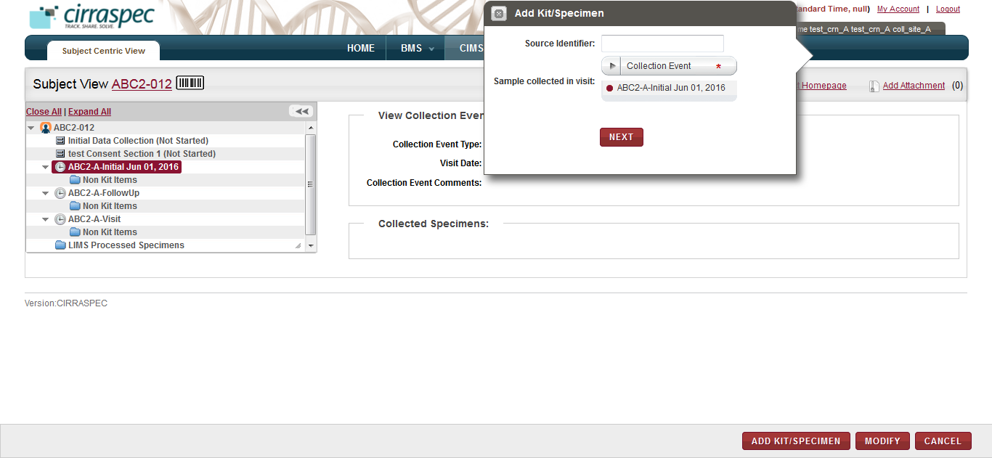

*Alternative Path:*

1. Click the **ADD KIT/SPECIMEN** button from the Subject Homepage
2. Select the required Collection Event from the dropdown on the ‘Add Kit/Specimen’ pop-up.
3. In the **Source Identifier** box, type the Identifier of the specimen you want to assign, and then click **NEXT**.

The ‘**Add Kits/Specimen’** pop-up page is displayed.

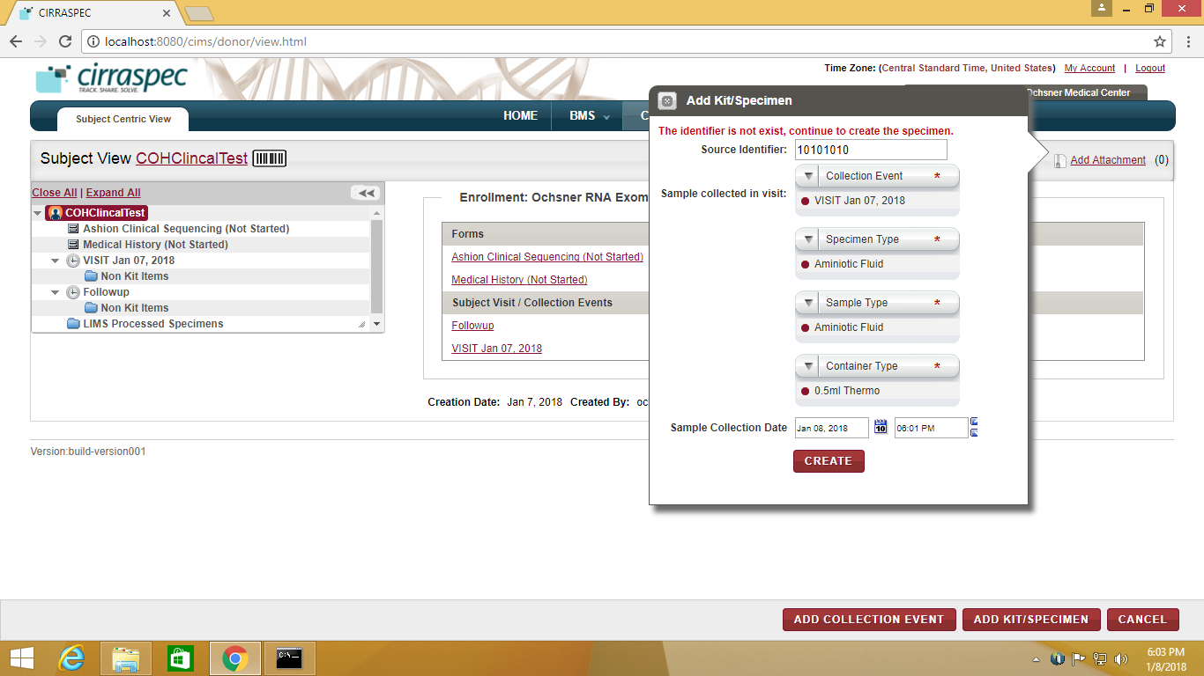

1. Click **CREATE**.   
   The specimen is assigned to the Collection Event for this Subject.

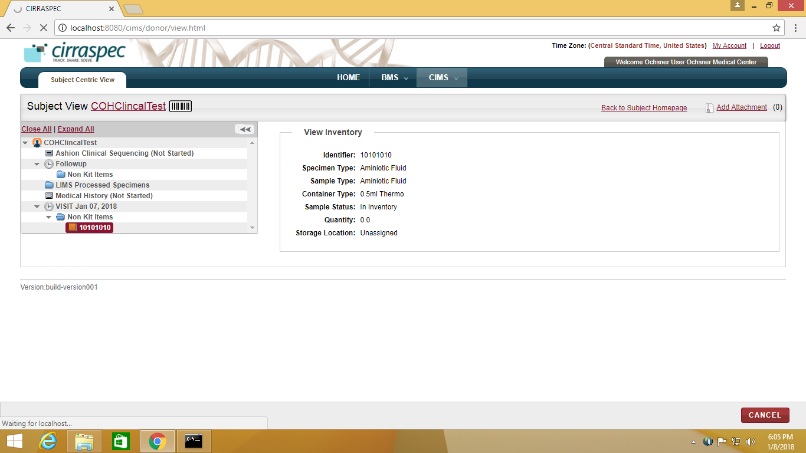

**Note:**

1. Specimen already assigned to a patient cannot be assigned to another patient.

### Ship the specimens to the Speciality Lab

To ship the specimens collected and assigned to patient:

1. On Specimen page, Click on “**Ship Specimens”** button**.**

**View Shipment** page appears.

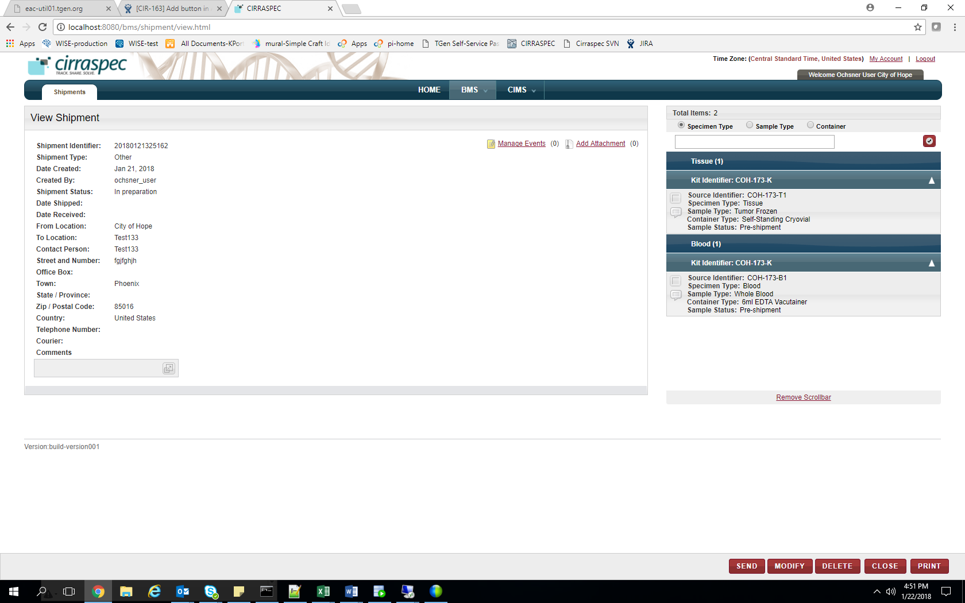

### Click SEND on the Shipment page.

**Send Shipment** page appears.

1. In the **Send Shipment Details** area, enter appropriate information in each field. Following table lists each field and its description.

**Note:** Fields that are marked with the red asterisk (\*) are mandatory.

| **Field** | **Description** |
| --- | --- |
| **Date Shipped**\* | Click the date icon Search calendar, and then click the date when you will send the shipment.  The date appears in the **Date Shipped** box. |
| **Courier**\* | Click appropriate shipping courier. |
| **Tracking Resource**\* | Type shipping courier’s tracking number. |
| **Transport Code** | Type transport code, if applicable. |
| **Comments** | Type comments, as needed. |
| **Sender’s Checklist** | Make sure all the checkboxes are selected and the respective actions have been taken. |

1. Click **SUBMIT**.

The shipment status and the biospecimens’ status changes to **In Transit** on the **View Shipment** page.

### Login and Download Patient Sample Report

An email notification as below will be sent to inform that the Patient report is available for download.

**From:** Ming Liang [[mailto:mliang@tgen.org](mailto:mliang@tgen.org" \t "_blank)]   
**Sent:** Friday, January 19, 2018 2:32 AM  
**To:** Sayali Dev <[Sayali\_Dev@persistent.com](mailto:Sayali_Dev@persistent.com" \t "_blank)>  
**Subject:** [Cirraspec] - Final Lab Report file has been uploaded onto COH-00003

File name : Lab Report.pdf  
Patient Identifier COH-00003

Once email is received, follow below steps to download and view the report :

* + 1. To Login into the application please refer to :[Login into Cirraspec](#_Logging_into_the)
    2. Point to the arrow on **CIMS** and Click on **Subject Centric View.**

The **Subject Search** page appears.

* + 1. Click on the row for the Subject Identifier

OR

To Search for the Subject use filters on left and Click on the row for the Subject.

The **Subject/Donor view** page appears as below.

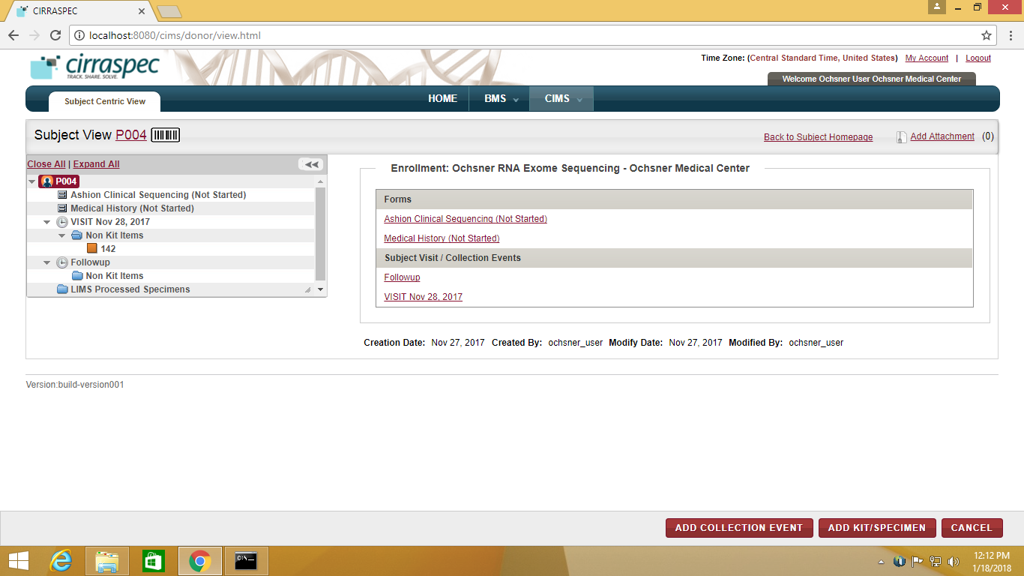

* + 1. Once the report is uploaded into the system, you will view the report uploaded under “**Documents**”:

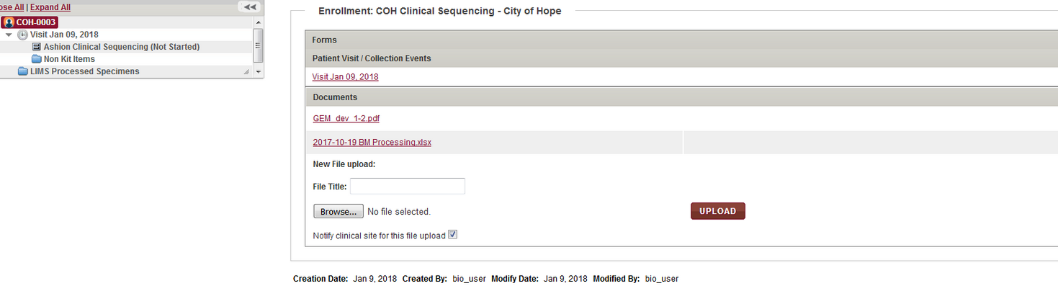

* + 1. Click on the report file link “GEM**-dev 1-2.pdf**”

Report is downloaded as a pdf. You can open the pdf to view the report.

Please find below a sample pdf report.



*Alternative Path:*

* + 1. On Home Page, Click on **Search Subject** link.

The **Subject Search** page appears.

* + 1. Follow above steps 3 – 5 to download patient report.

### Reordering or Adding another order for a test for a Patient

To add another order for a test for a patient:

1. Point to the arrow of the **CIMS** tab, and then click **Subject Centric View**.

The **Subject Search** page appears.

1. Click **SEARCH**.

The Subject Search page displays a list of Subjects.

1. Click the row of the Subject that you want to update.

The **Subject View** page appears.

1. Click **ADD COLLECTION EVENT** button at the right bottom of the page

The **Add Collection Event** area appears on the right.  
  
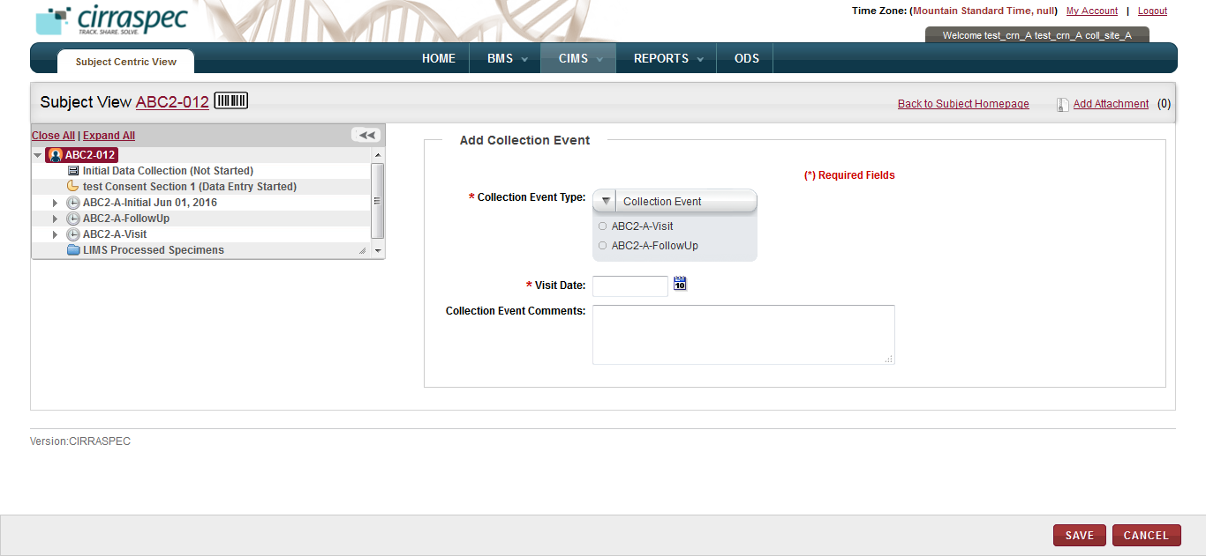

1. Select the **Collection Event Type**.
2. Select the **Visit Date**.
3. Input **Collection Event Comments**, if needed.
4. Click **SAVE**.The Collection Event information is saved.

**Note**: Refer to:

**[Completing requisition forms](#_Completing_Requsition_Forms)** to complete requisition form for the order.

**[Assigning a Collected Specimen to a Patient](#_Assigning_Collected_Specimen)** to assign a specimen for the added collection event for the order placed